Adding list ing of Modules that arent communicating
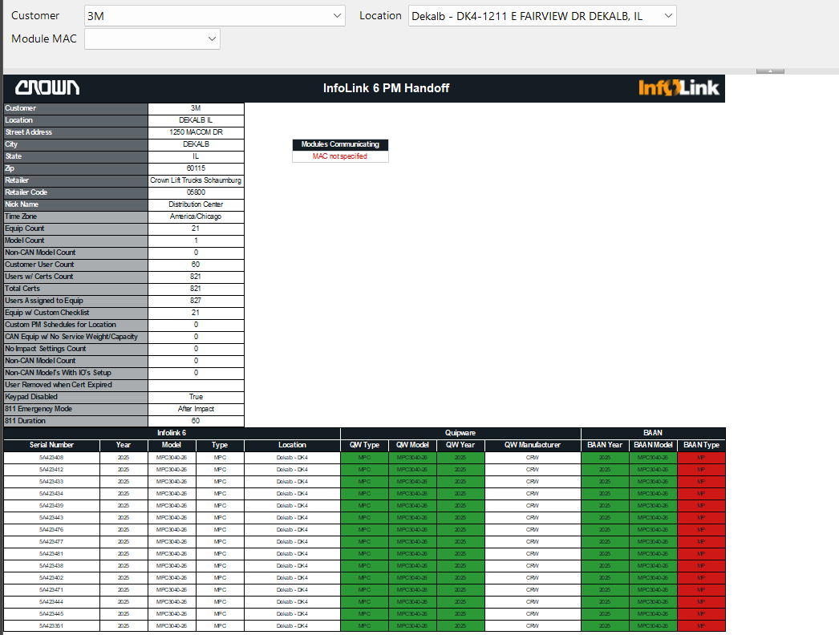

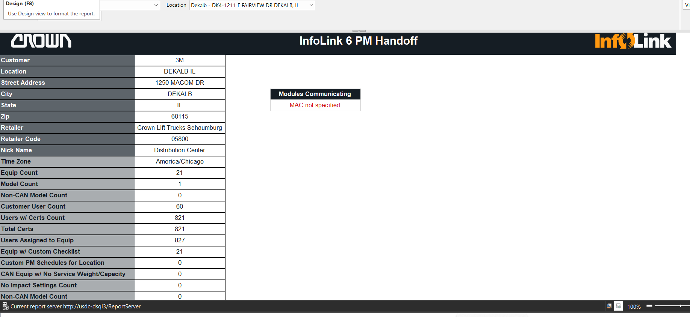
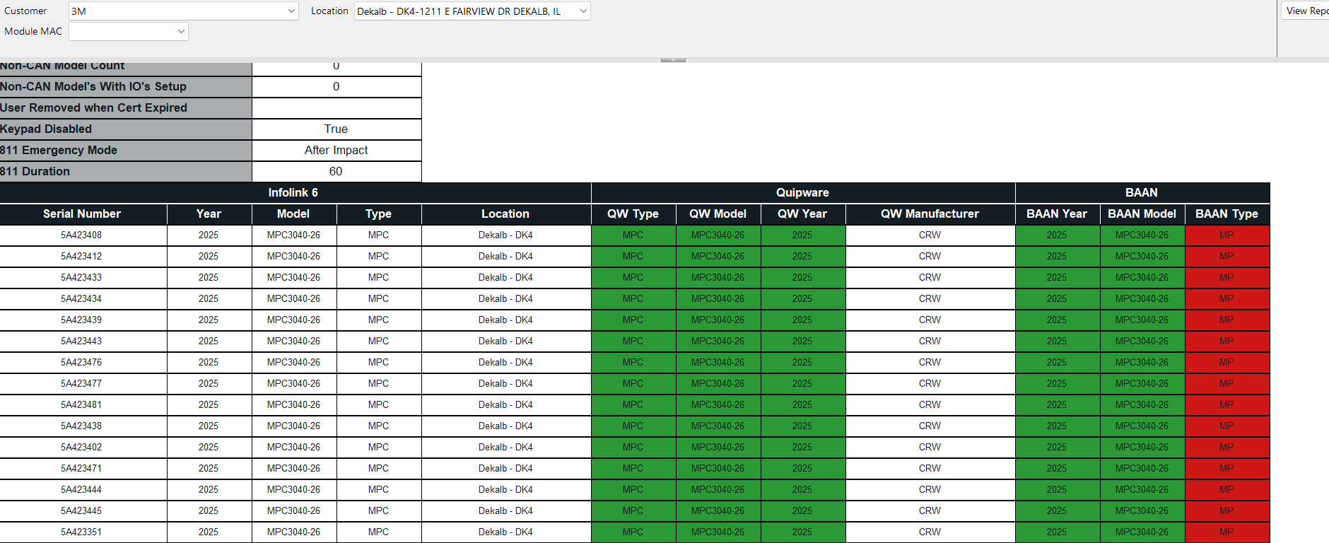
OLD ticket
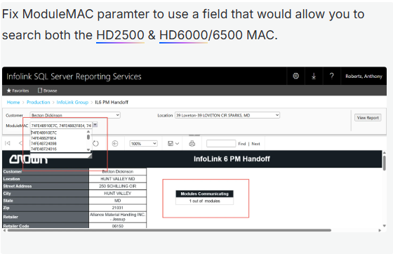

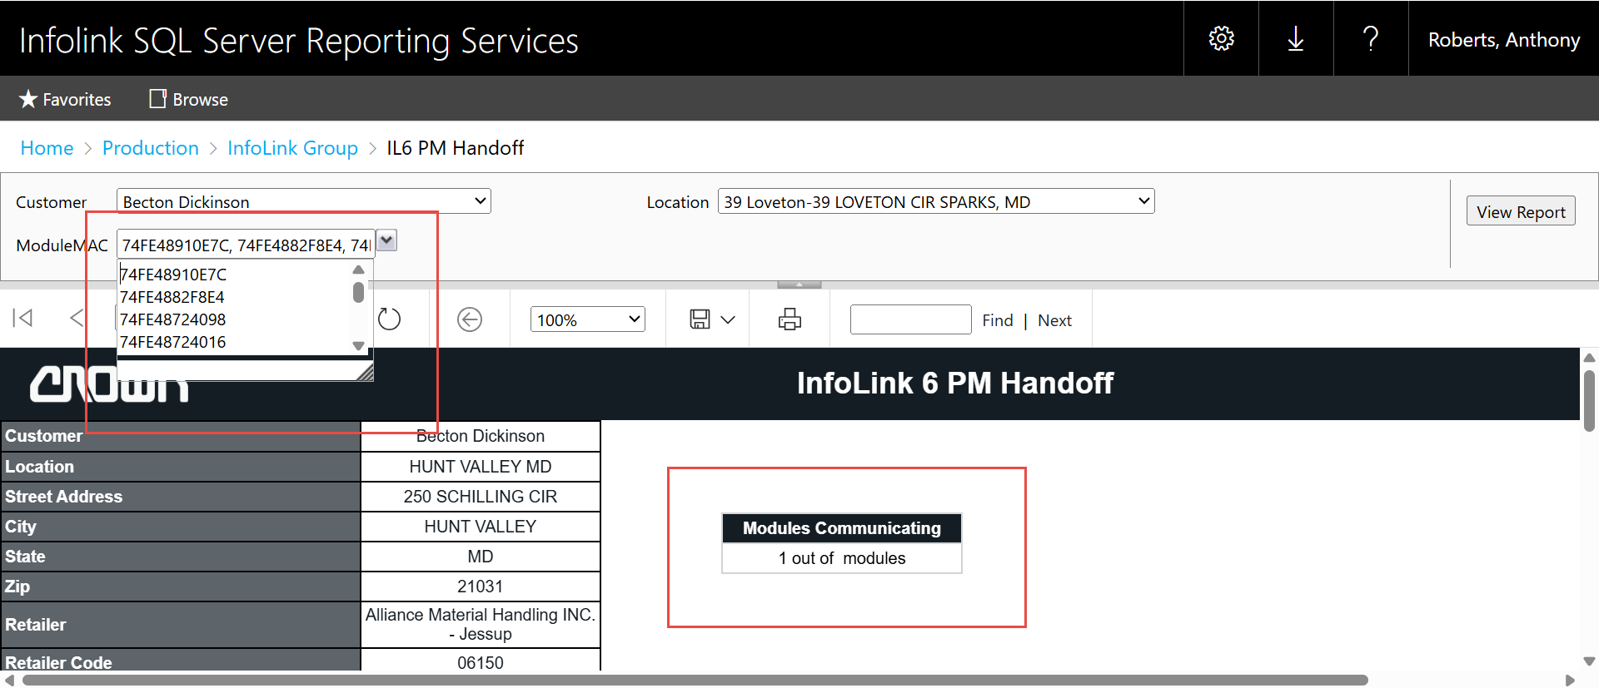

- Luke Davidson
March 30, 2026 at 9:40 AM
Push to Prod requested on 3/27
Report Name: IL6 PM Handoff (SSRS Update)
Developer: luke.davidson@crown.com
Description: IL6 PM Handoff report is now updated to take the WiFi MAC Address for HD2500/3000/3500 & HD6000/65000 setups. The modules communicating text box now shows the correct count of modules listed in Module MAC parameter, and the amount of communicating modules.

Please respond if any details or pictures should be added.
The top portion of this email will be provided to the stakeholders once the report is published.

Priority: Normal
Stakeholders: Cason White, Anthony Roberts, Derek Bertke, Greg Berning
Jira Ticket: LS-11968: Fix IL6 PM Handoff BugDone
Dev File: http://usdc-dsql3/Reports/manage/catalogitem/properties/Infolink%20Dev/Luke/IL6%20PM%20Handoff
Sub-report Link(s):
Parameter Changes: Prompt for ModuleMAC changed from "ModuleMAC" to "Module MAC"
Notes: IL6 PM Handoff report is now updated to take the WiFi MAC Address for HD2500/3000/3500 & HD6000/65000 setups. The modules communicating text box now shows the correct count of modules listed in Module MAC parameter, and the amount of communicating modules.

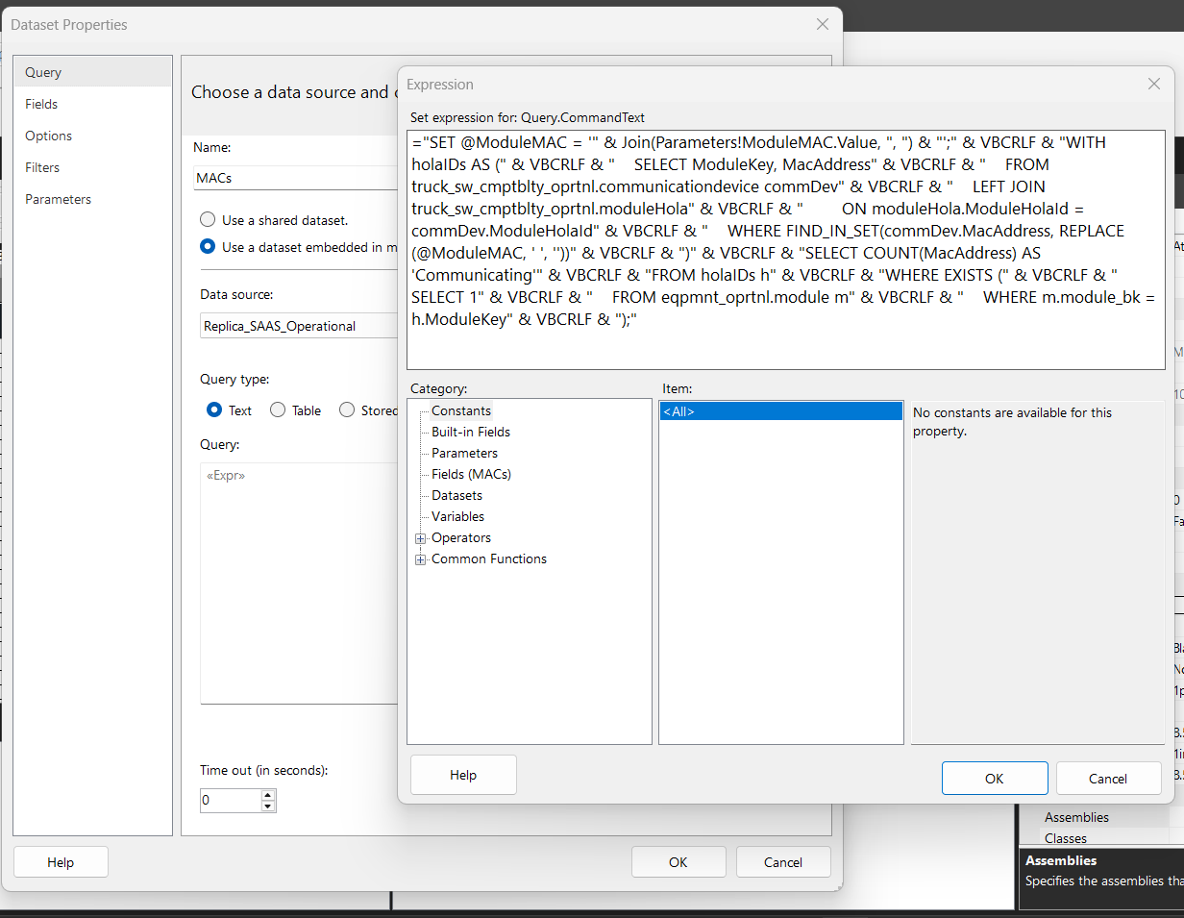

="SET @ModuleMAC = '" & Join(Parameters!ModuleMAC.Value, ", ") & "';" & VBCRLF & "WITH holaIDs AS (" & VBCRLF &
" SELECT ModuleKey, MacAddress" & VBCRLF &
" FROM truck_sw_cmptblty_oprtnl.communicationdevice commDev" & VBCRLF &
" LEFT JOIN truck_sw_cmptblty_oprtnl.moduleHola" & VBCRLF &
" ON moduleHola.ModuleHolaId = commDev.ModuleHolaId" & VBCRLF &
" WHERE FIND_IN_SET(commDev.MacAddress, REPLACE(@ModuleMAC, ' ', ''))" & VBCRLF &
")" & VBCRLF &
"SELECT COUNT(MacAddress) AS 'Communicating'" & VBCRLF &
"FROM holaIDs h" & VBCRLF &
"WHERE EXISTS (" & VBCRLF &
" SELECT 1" & VBCRLF &
" FROM eqpmnt_oprtnl.module m" & VBCRLF &
" WHERE m.module_bk = h.ModuleKey" & VBCRLF &
");"

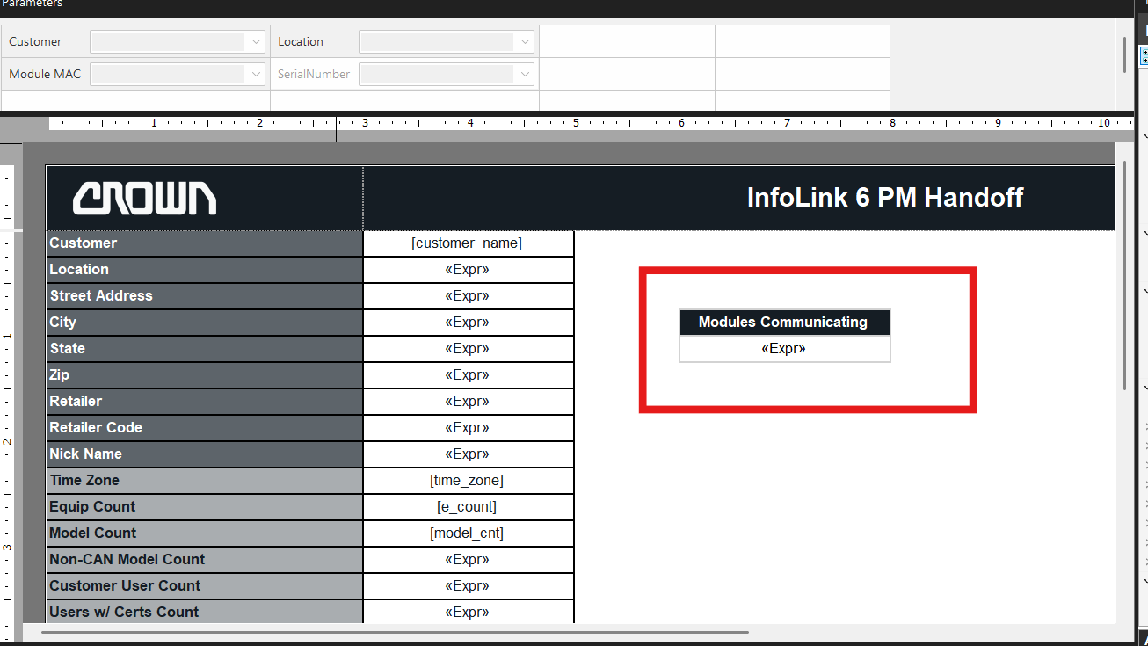
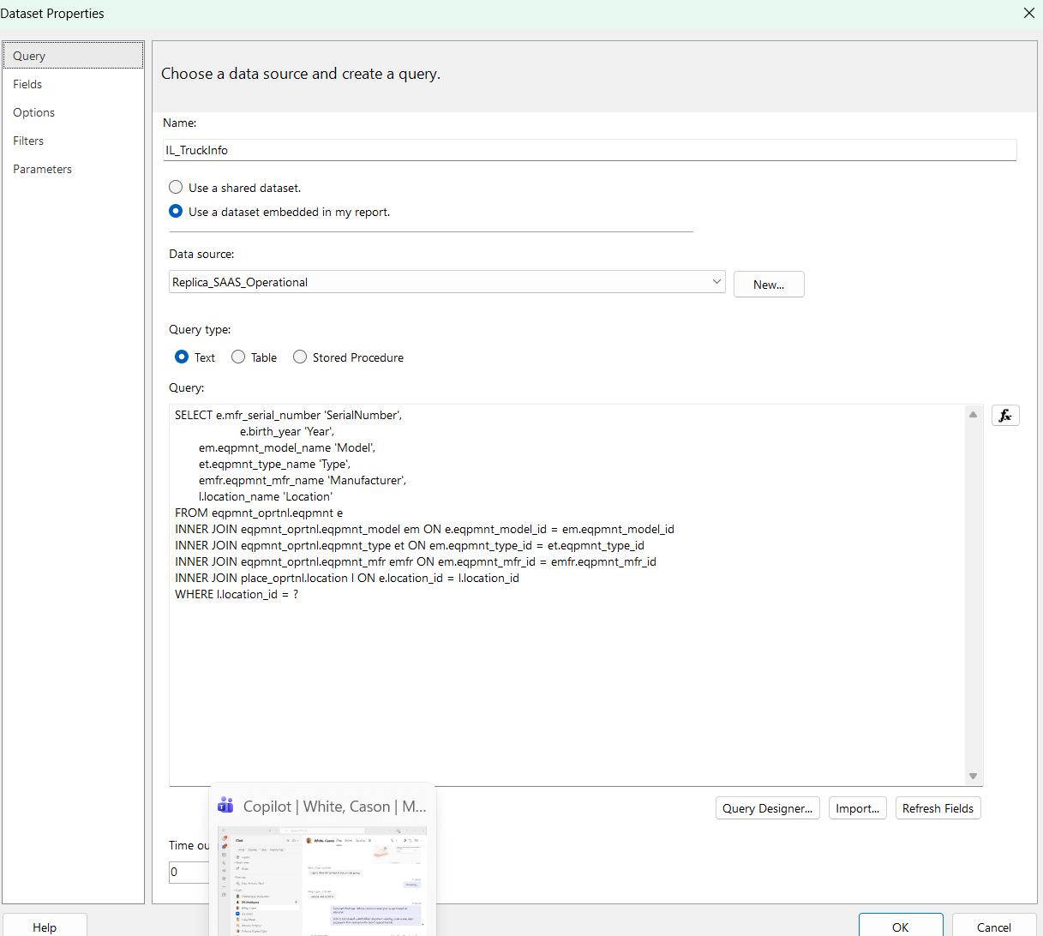
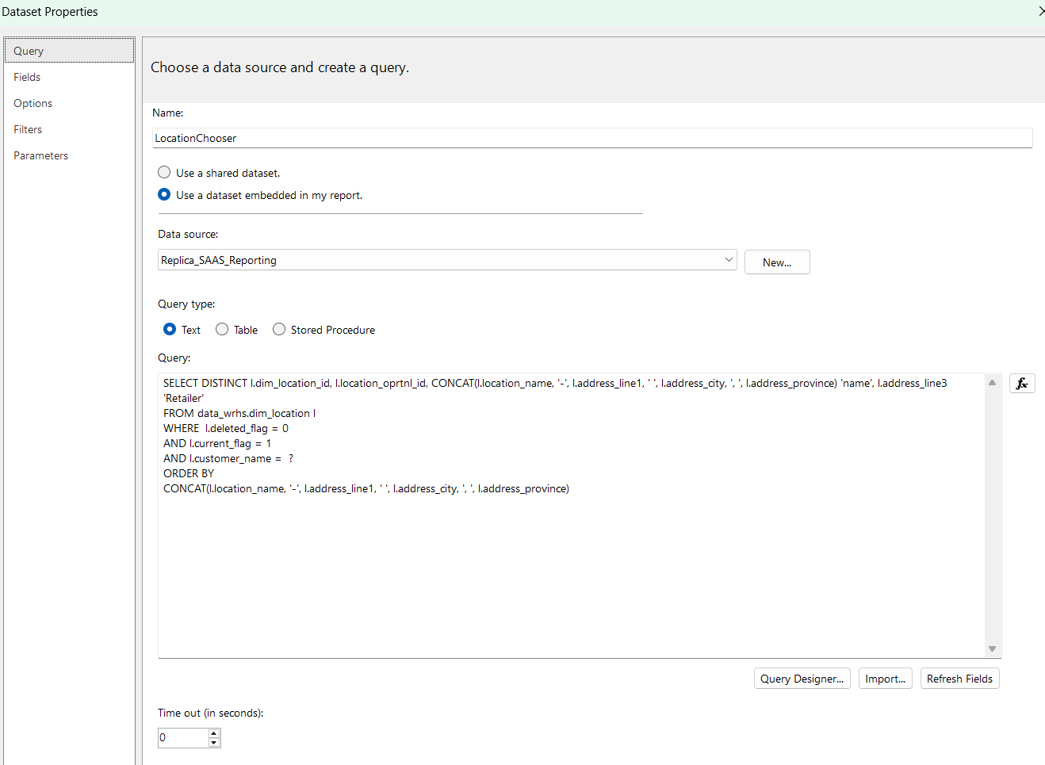
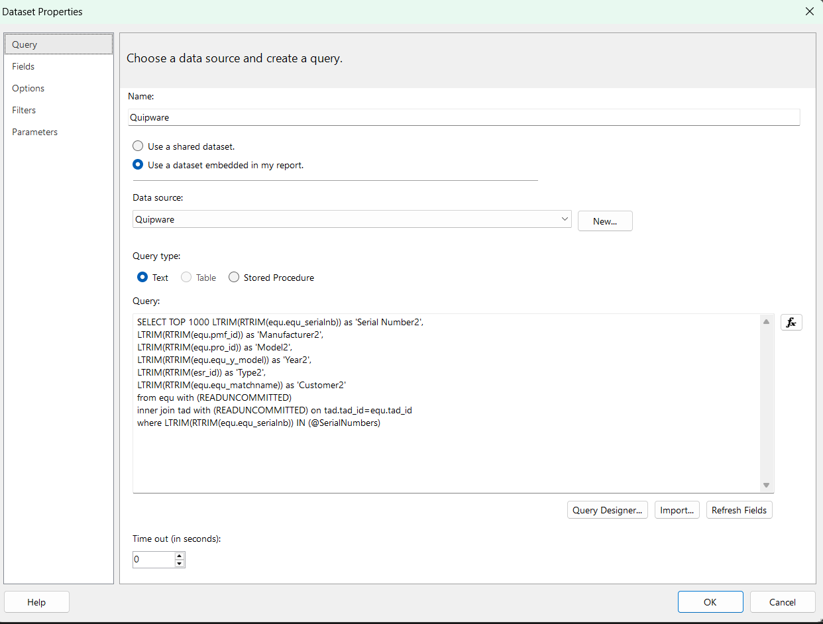
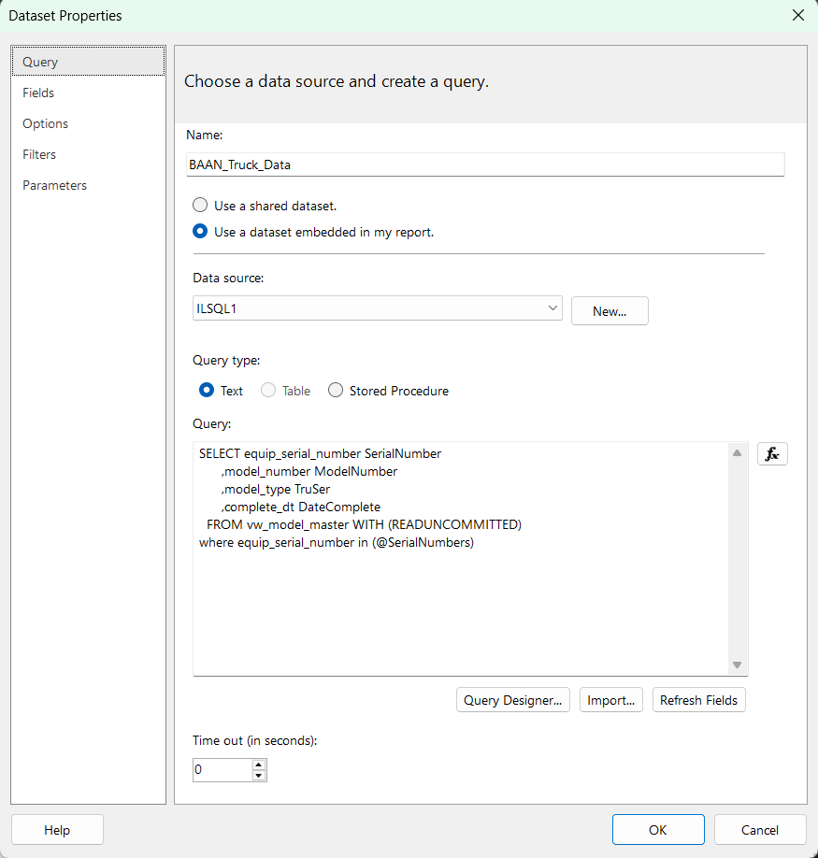

Operational Query

WITH cust_loc AS (
SELECT
cust.customer_id,
cust.customer_name,
l.location_id,
l.tz_bk 'time_zone'
FROM
place_oprtnl.customer cust
INNER JOIN place_oprtnl.location l ON cust.customer_id = l.customer_id
WHERE
l.location_id = ?
),
userLocations AS (
SELECT
user_id,
ul.location_id,
customer_id
FROM
user_oprtnl.user_location ul
JOIN cust_loc cl ON ul.location_id = cl.location_id

UNION ALL

SELECT
uc.user_id,
cl.location_id,
uc.customer_id
FROM
user_oprtnl.user_customer uc
JOIN user_oprtnl.user_profile up ON up.user_id = uc.user_id AND all_location_flag = 1
JOIN cust_loc cl ON uc.customer_id = cl.customer_id
),
certs AS (
SELECT
COUNT(DISTINCT crt.user_id) 'users_w_certs',
COUNT(crt.user_cert_id) 'total_certs'
FROM
user_oprtnl.user_cert crt
INNER JOIN userLocations ul ON crt.user_id = ul.user_id
),
equip_assigned AS (
SELECT
COUNT(DISTINCT eu.user_id) 'users_assigned_equip'
FROM
eqpmnt_usr_oprtnl.eqpmnt_user eu
JOIN userLocations ul ON eu.user_id = ul.user_id
LEFT JOIN user_oprtnl.user_profile up ON eu.user_id = up.user_id
WHERE
up.email_address NOT LIKE '%@crown.com'
AND up.email_address NOT LIKE '%@exmple.com'
OR up.email_address IS NULL
),
non_def_checklst AS (
SELECT
COUNT(chk.chcklst_id) 'checklist_count'
FROM
chcklst_oprtnl.chcklst chk
JOIN cust_loc cl ON chk.customer_id = cl.customer_id
WHERE
chk.chcklst_name NOT LIKE 'Default%'
),
no_srv_wt AS (
SELECT
COUNT(*) 'no_srvc_weight'
FROM
eqpmnt_oprtnl.eqpmnt e
JOIN eqpmnt_oprtnl.eqpmnt_model em ON e.eqpmnt_model_id = em.eqpmnt_model_id
JOIN cust_loc cl ON e.location_id = cl.location_id
WHERE
e.service_weight_kg IS NULL
AND em.wired_io_flag = 1
),
no_impact_setting AS (
SELECT
COUNT(*) 'no_imp_setup'
FROM
eqpmnt_oprtnl.eqpmnt e
JOIN cust_loc cl ON e.location_id = cl.location_id
LEFT JOIN eqpmnt_oprtnl.eqpmnt_impact_setting s ON e.model_impact_settings_flag = 1
AND e.eqpmnt_id = s.eqpmnt_id
AND s.sensor_type_text_id = 'POWERUNIT'
LEFT JOIN eqpmnt_oprtnl.model_impact_setting mis ON e.model_impact_settings_flag = 0
AND e.eqpmnt_model_id = mis.eqpmnt_model_id
AND mis.sensor_type_text_id = 'POWERUNIT'
WHERE
COALESCE(s.thrshld_high_x, mis.thrshld_high_x) & COALESCE(s.thrshld_high_y, mis.thrshld_high_y) = 0
),
cust_usr_cnt AS(
SELECT
COUNT(up.user_id) 'customer_user_count'
FROM
user_oprtnl.user_profile up
JOIN userLocations ul ON up.user_id = ul.user_id
WHERE
up.email_address NOT LIKE '%@crown.com'
AND up.email_address NOT LIKE '%@exmple.com'
OR up.email_address IS NOT NULL
),
no_def_chcklst AS(
SELECT
COUNT(e.eqpmnt_id) 'equip_w_checklist'
FROM
eqpmnt_oprtnl.eqpmnt e
JOIN cust_loc cl ON e.location_id = cl.location_id
JOIN chcklst_oprtnl.chcklst chk ON e.chcklst_id = chk.chcklst_id
WHERE
chk.chcklst_name NOT LIKE '%Default%'
),
em_noncan AS (
SELECT
COUNT(DISTINCT e.eqpmnt_id) 'equip_count_noncan',
COUNT(DISTINCT e.eqpmnt_model_id) 'equip_model_count_noncan'
FROM
eqpmnt_oprtnl.eqpmnt e
JOIN eqpmnt_oprtnl.eqpmnt_model em ON e.eqpmnt_model_id = em.eqpmnt_model_id AND em.wired_io_flag = 1
JOIN cust_loc cl ON e.location_id = cl.location_id
),
eqpmnt_count AS(
SELECT
COUNT(e.eqpmnt_id) 'e_count'
FROM
eqpmnt_oprtnl.eqpmnt e
JOIN cust_loc cl ON e.location_id = cl.location_id
),
eqpmnt_model_cnt AS (
SELECT
COUNT(DISTINCT eqpmnt_model_id) 'model_cnt'
FROM
eqpmnt_oprtnl.eqpmnt e
JOIN cust_loc cl ON e.location_id = cl.location_id
),
keypad_setting AS (
SELECT
ds.keypad_enabled_flag
FROM
eqpmnt_sttng_oprtnl.display_setting ds
JOIN cust_loc cl ON ds.customer_id = cl.customer_id
ORDER BY
update_dt_UTC
LIMIT
1
),
emergency_setting AS (
SELECT
CASE es.override_flag
WHEN 0 THEN 'After Impact'
ELSE 'Anytime'
END 'override_flag',
es.duration_sec
FROM
eqpmnt_sttng_oprtnl.emrgncy_setting es
JOIN cust_loc cl ON es.customer_id = cl.customer_id
),
cert_expire_remove AS (
SELECT
remove_operator_flag
FROM
eqpmnt_sttng_oprtnl.cert_setting cset
JOIN cust_loc cl ON cset.customer_id = cl.customer_id
)

SELECT
*
FROM
cust_loc
JOIN certs
JOIN equip_assigned
JOIN non_def_checklst
JOIN no_srv_wt
JOIN no_impact_setting
JOIN cust_usr_cnt
JOIN no_def_chcklst
JOIN em_noncan
JOIN eqpmnt_count
JOIN eqpmnt_model_cnt
JOIN keypad_setting
JOIN emergency_setting
JOIN cert_expire_remove
Reporting Query

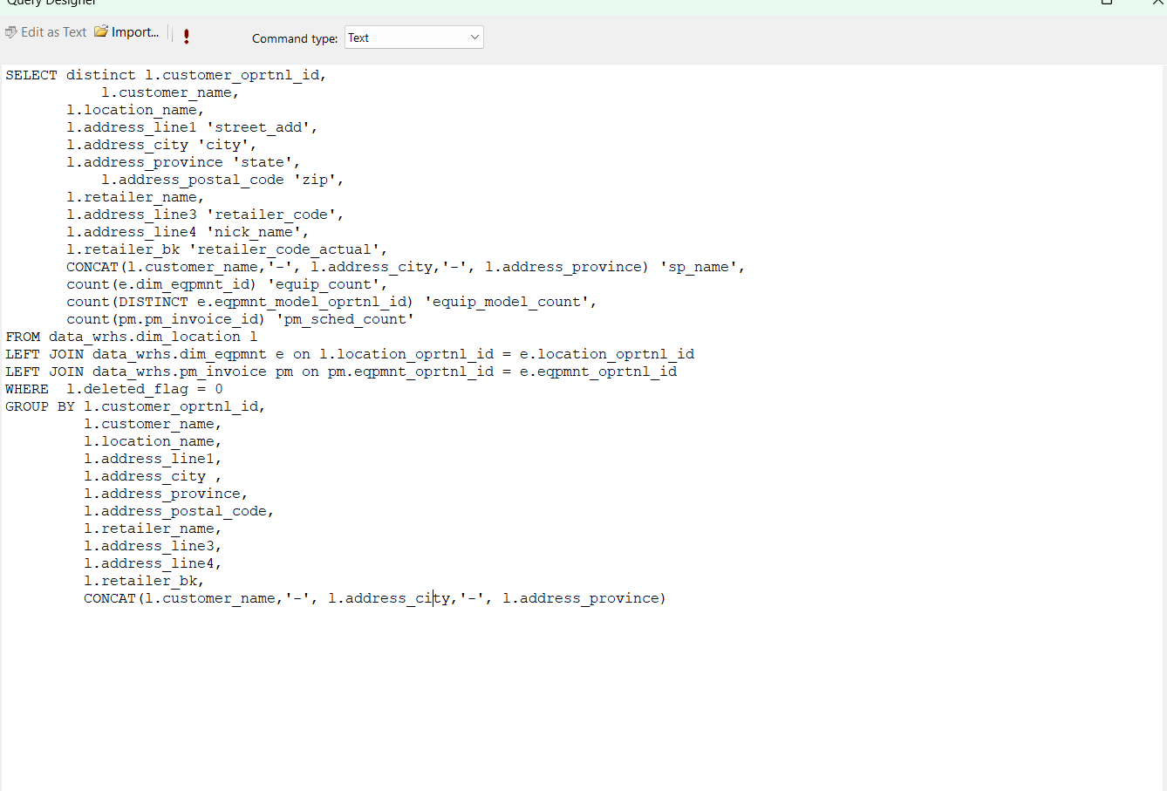

Original Ticket
Hey Jake,

I might have missed it, but on the IL6 page, there is not a note on count of expired certs? Also the modules communicating is always 1 out of 1? Even if you have more than 1 module?

IL6 PM Handoff - SQL Server Reporting Services
there is not a note on count of expired certs?
IL4 Example
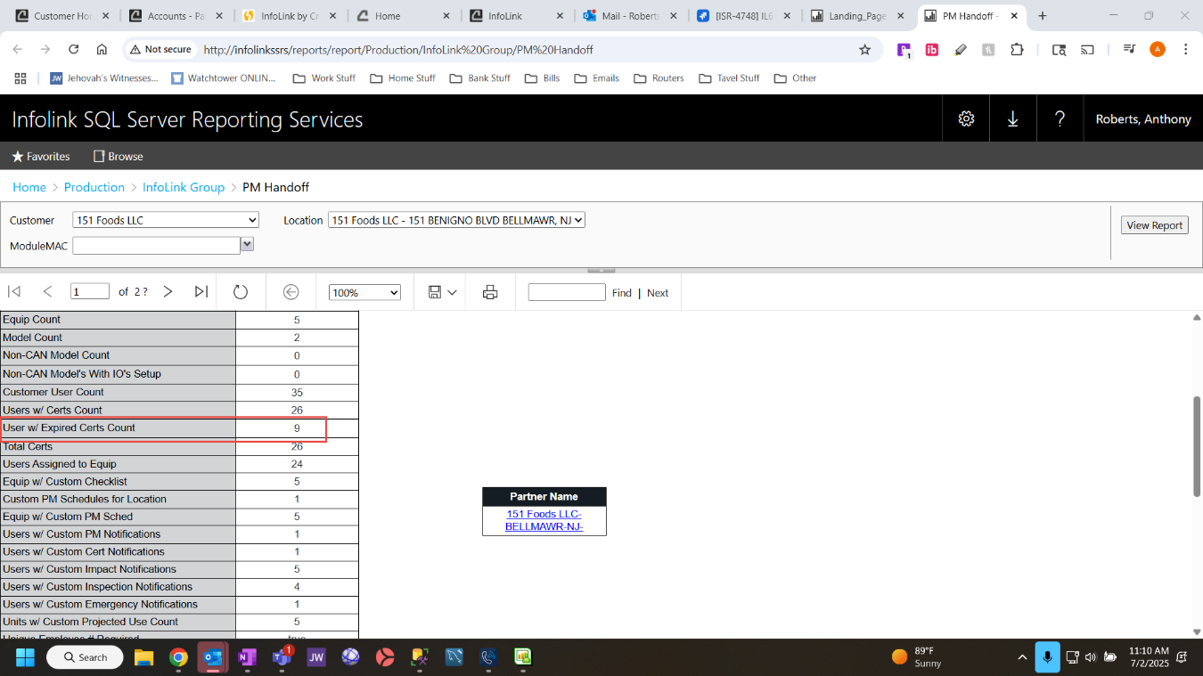

Also the modules communicating is always 1 out of 1? Even if you have more than 1 module?
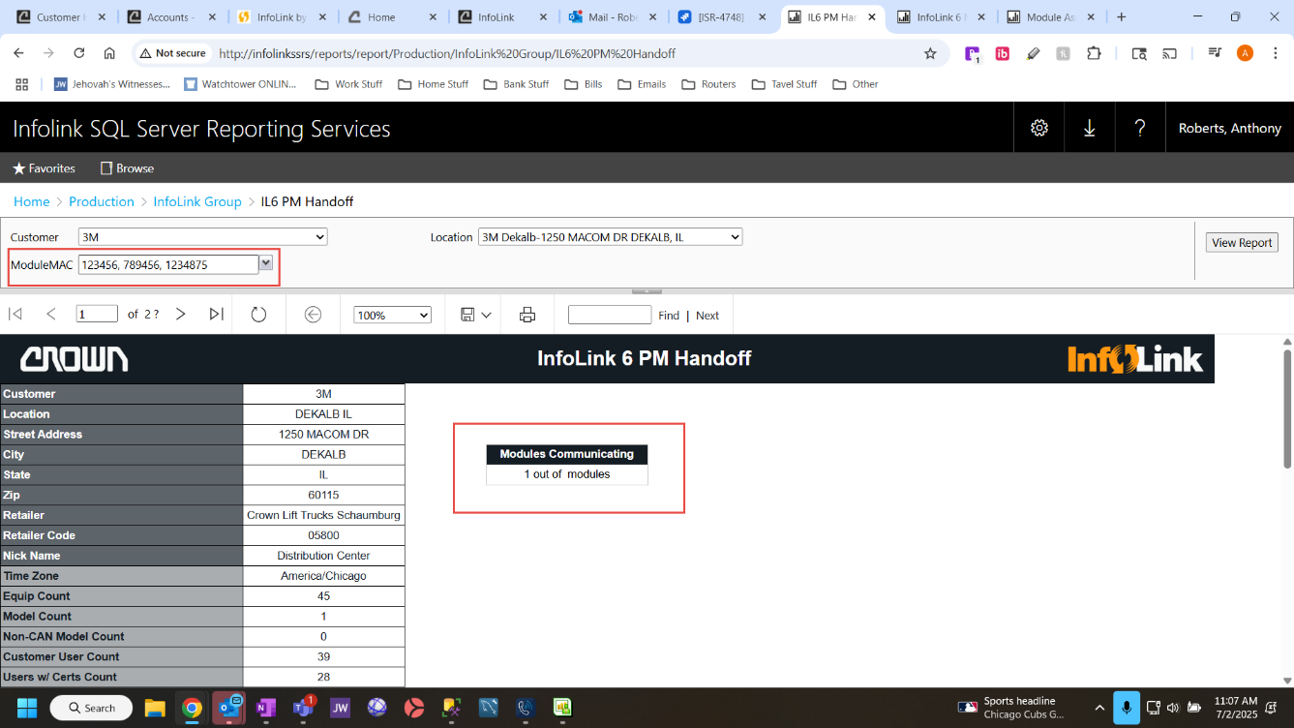

Also need use the MAC Address field so the HD6000 units can be used for this report.
